Getting Started with Modeler

January 24, 2013

Launch IBM SPSS Modeler

The large white space in the center is the “palette” that will be used to create a program or stream. The upper right hand corner box can be used to display output or modeling results or a list of streams if more than one is open.

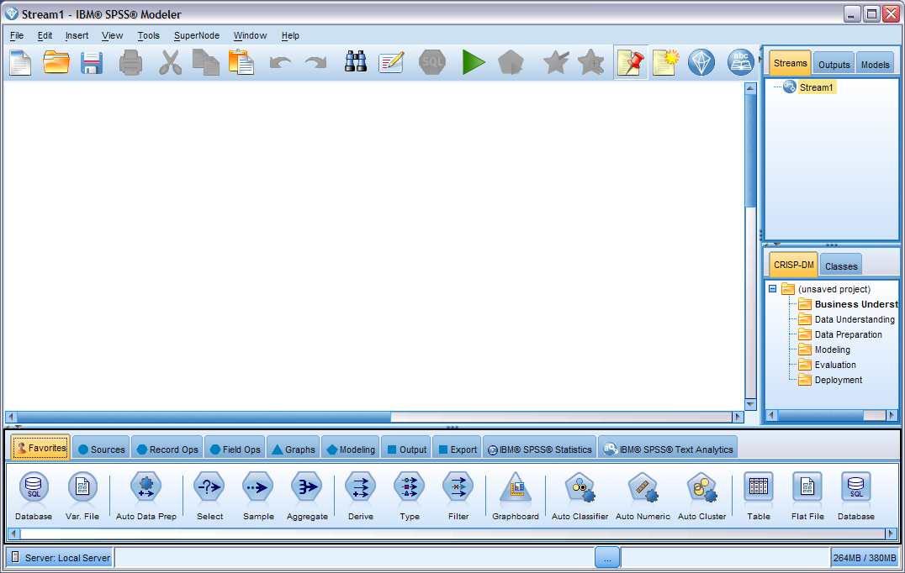

Go to the Source tab at the bottom and double click on the Statistics File icon. It will be placed on the palette as below.

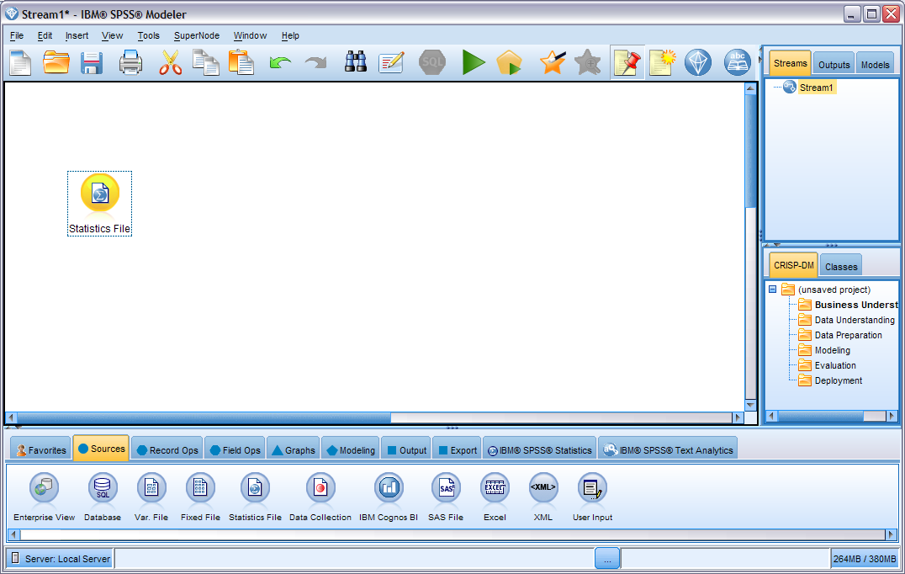

Click on the Statistics File node and browse to the customer_dbase.sav file in the Modeler directory under Program Files on your machine. The path will be different than the one shown here. Once you have located the file, click on Apply and then the Types tab. This should produce the second screen shot shown below with the field names and properties.

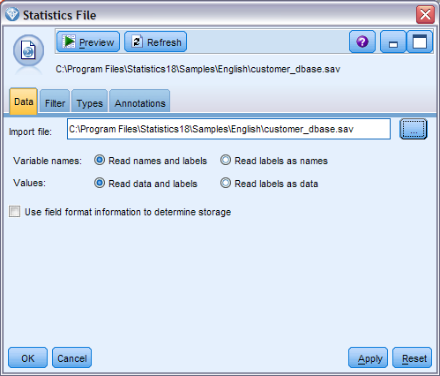

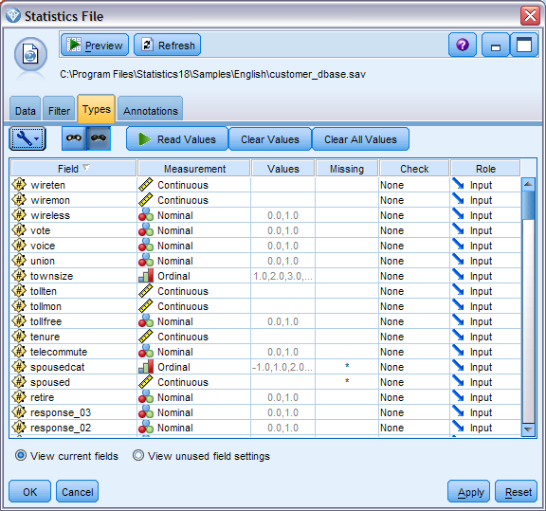

Click on Output tab in the lower panel to see the icons shown below.

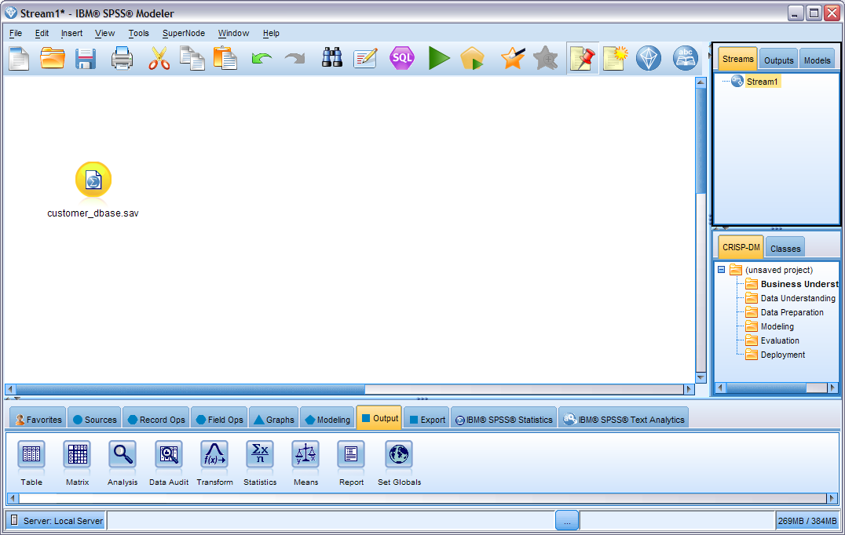

Double click on the Data Audit node with the customer_dbase.sav node highlighted to attach them.

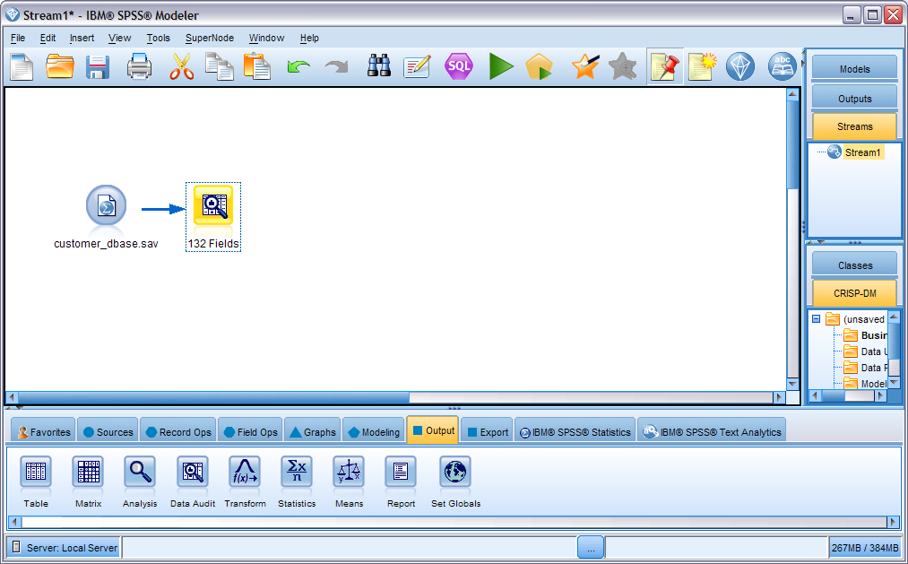

Double click on Data Audit to open the node and then select Run.

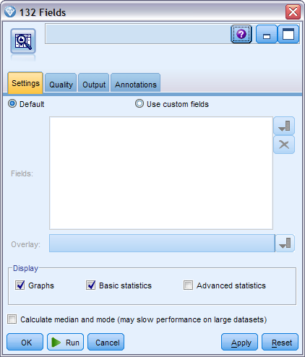

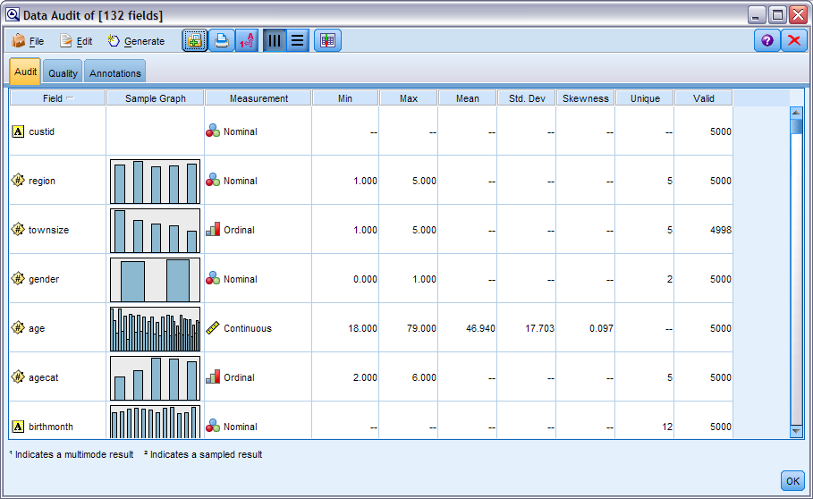

Click on the Field Ops tab to show the nodes below.

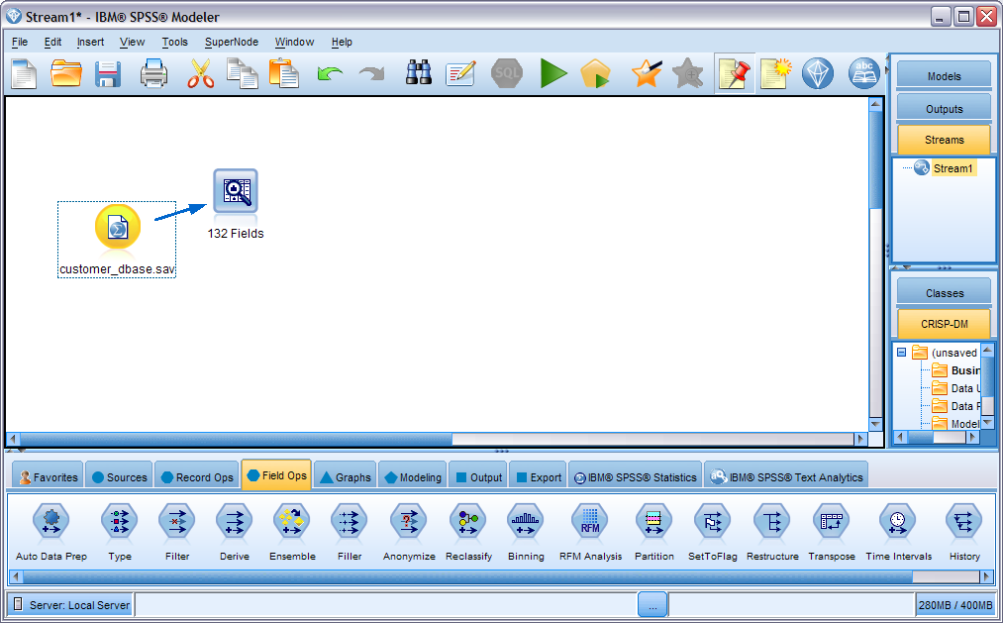

Double click on Type node to attach it to the customer_dbase.sav node.

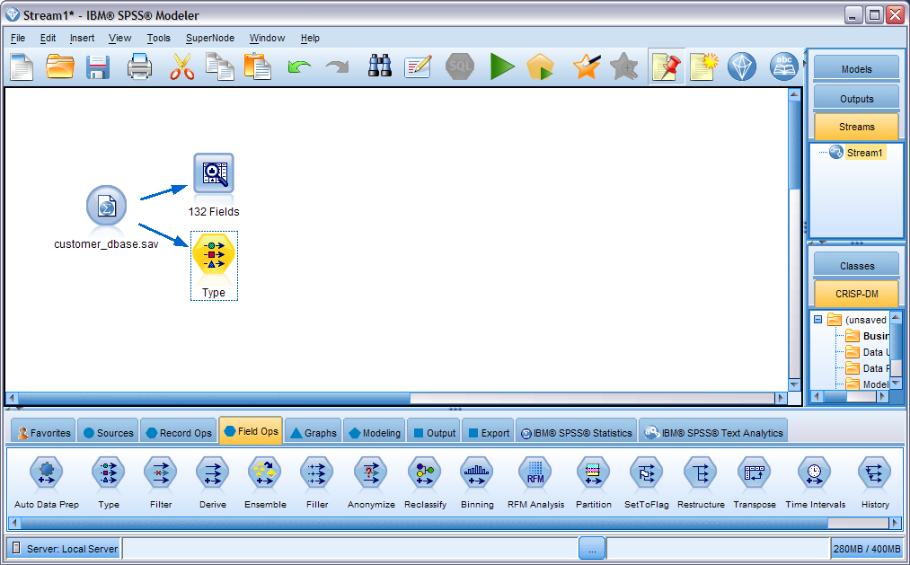

Open Type node and scroll down to “churn” field. Click on Input under the Role column and change the setting to Target.

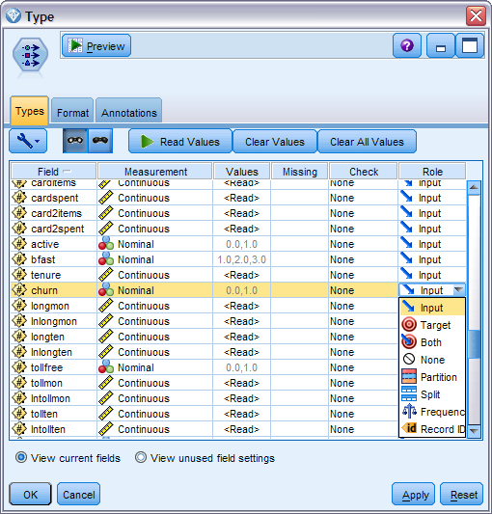

Click on the Modeling tab to display the modeling nodes shown below

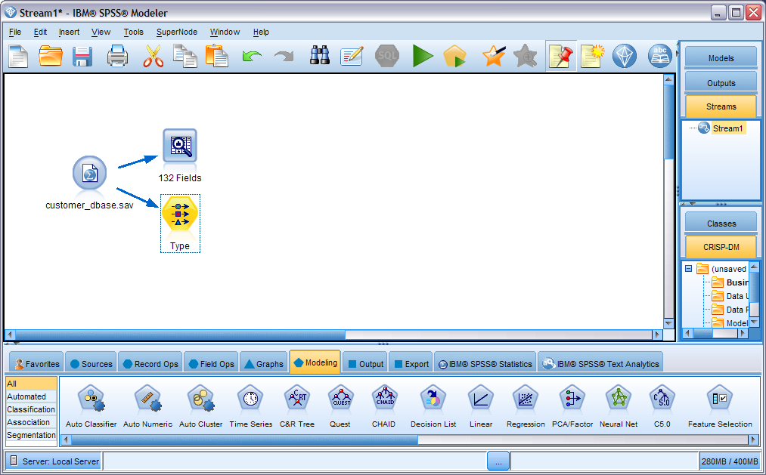

With the Type node highlighted, double click on the C5 icon to attach the two nodes. Notice the Churn label on the C5 node. This indicates the “target” for the modeling.

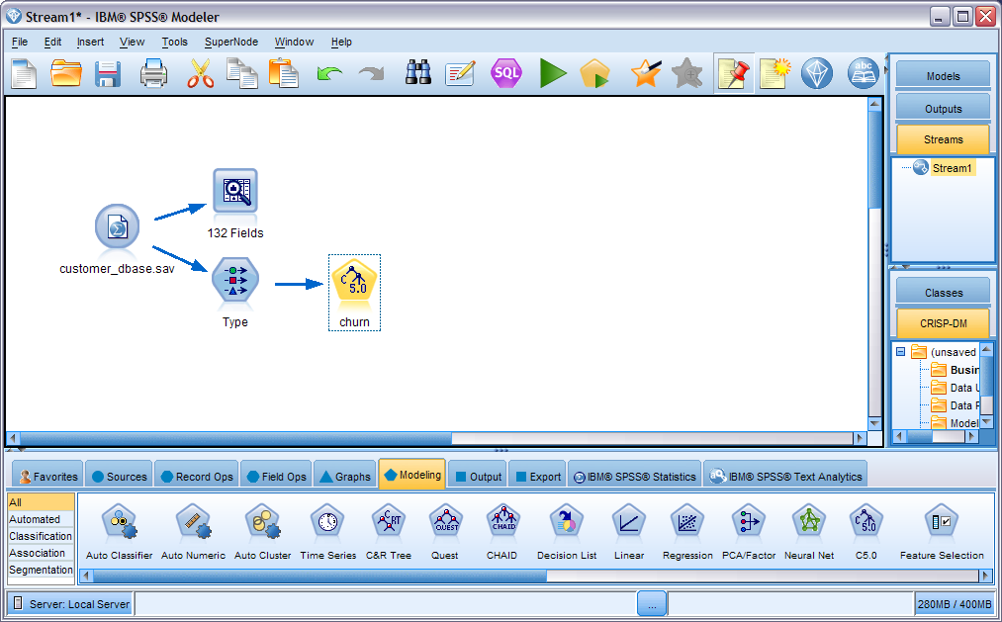

Right click on the C5 node and select Run. The processing will take a few minutes since we left all the fields as inputs.

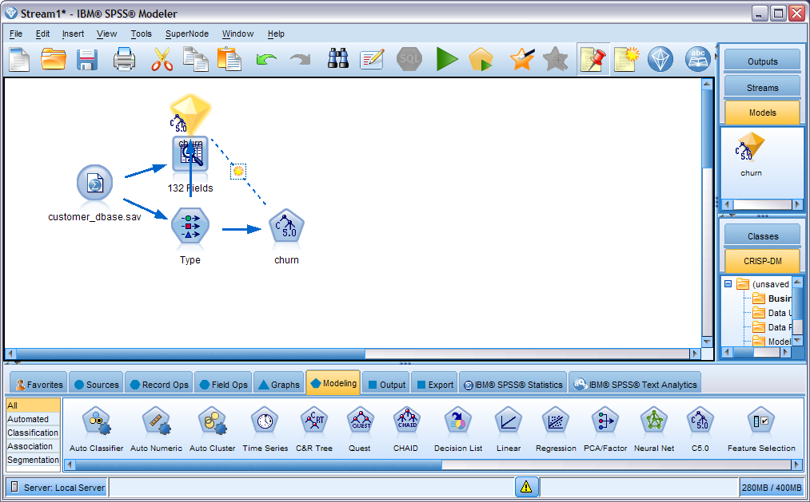

Right click on the C5 “diamond” and select Edit.

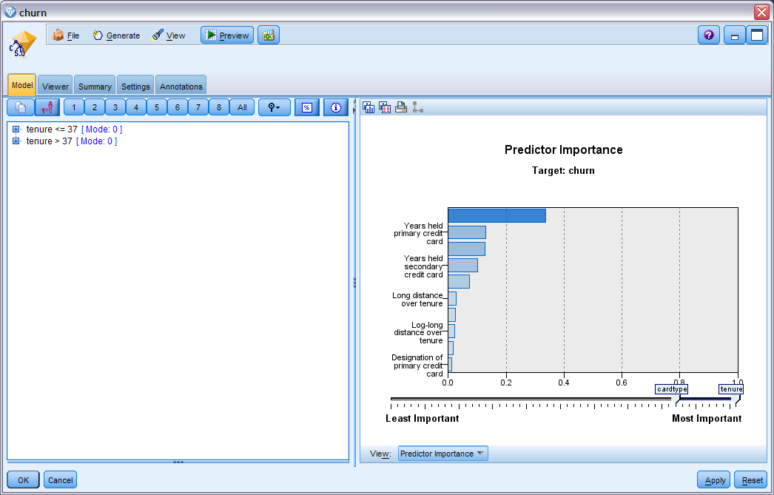

Click on the + symbol next to Tenure and expand the rules. Click on the % symbol to add detail.

